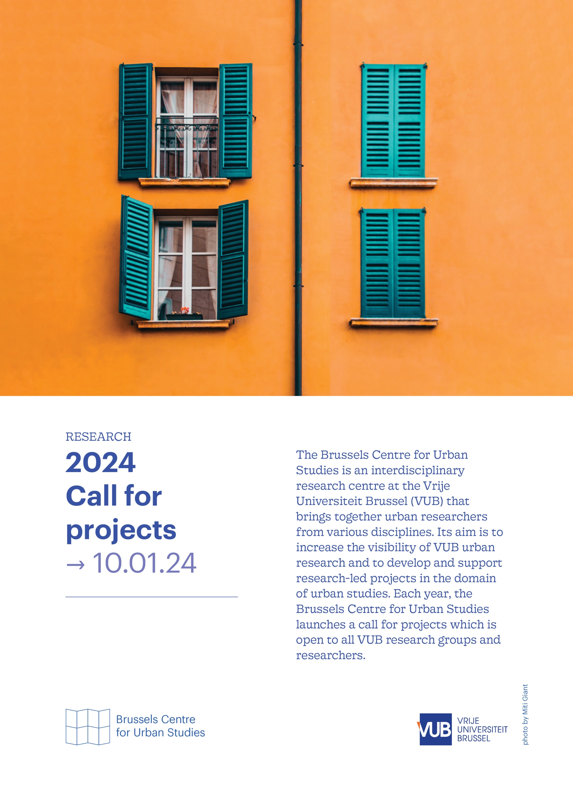
Call for Projects 2024 – Application form

Based at the Faculty of Geography and situated in the European capital, the Brussels Centre for Urban Studies seeks to support and widen an urban research environment at the Vrije Universiteit Brussel (VUB). The Centre offers an intellectual hub for more than twenty research groups and two hundred researchers with the aim to increase the visibility of VUB urban research(ers) and develop and support inter- and transdisciplinary collaborative urban research projects.

The Brussels Centre for Urban Studies is excited to announce its fifth call for projects, open for all VUB research groups and researchers. This call welcomes a diverse range of projects, with the only requirement being their alignment with the Brussels Centre for Urban Studies' mission and their engagement with the three core research questions that steer the Centre's endeavours.

Please use this application form and submit it via e-mail to the Centre’s research coordinator Lena Imeraj (Lena.Imeraj@vub.be) on 10 January 2024 at the latest.

main applicant
name:
VUB research group:
contact e-mail:

collaborations
If the proposed project involves a structured collaboration with other research groups (VUB or non-VUB (national and international)) and/or non-academic actors/organisations (NGO’s, public administrations, companies, civil society networks, cultural sector), list their details here.
collaboration 1
name:
research group or organisation:
contact e-mail:
collaboration 2
name:
research group or organisation:
contact e-mail:
collaboration 3
name:
research group or organisation:
contact e-mail:
collaboration 4
name:
research group or organisation:
contact e-mail:

project title

project abstract (max. 250 words)

project summary (max. 1500 words)

project relevance (max. 1500 words)
Your project proposal should address at least one of the primary dimensions and inquiries that inform the Center's work. In this section, please specify which dimensions are incorporated into your project proposal and describe how. A focus on Brussels is optional but appreciated in the evaluation.
inter- and transdisciplinarity Given the multitude of disciplinary viewpoints on cities and ‘the urban’, what are the principal analytical approaches informing your project? Can you identify theoretical and thematic concerns as well as analytical concepts and heuristics that facilitate genuinely inter- and/or transdisciplinary urban research?
comparative urbanism Considering the socio-spatial unevenness in global urban development, could you elaborate on how your proposed project addresses both commonalities and differences among cities across space? In light of recent critiques on the city-centric bias of urban studies, how does your project move beyond a focus on the urban core of a limited set of cities and instead give substantive consideration to urban ‘peripheries’ and broader dynamics of urbanisation?
engaged research Embracing the situated nature of urban research, to what extent does your proposed project foster collaboration between academia and other actors and networks, such as NGOs, civil society, government administrations and businesses? How does this shape the kind of urban knowledge generated by your project, and how does this create opportunities for engaged urban research?

project plan and timing (max. 1500 words)
Could you provide specific details regarding your proposed actions? Please outline your project plan, including a timeline specifying when you intend to execute each task.

project output (max. 1500 words)
What are the expected results or outcomes of your proposed project? Identify clearly how these outputs align with your project plan and the Centre’s overarching research questions. Don’t hesitate to think outside the box: next to the ‘usual’ academic output of seminars, journal articles and funding applications, we are eager to support new and original forms of research-led public engagement.

project budget (max. 1000 words)
Please provide details of your project budget, including a breakdown of anticipated expenses. If your project is receiving funding from sources other than the Brussels Centre for Urban Studies, specify the relationship between the Centre's support and the total budget. Project funding can cover various expenses such as catering, room rental, travel, staff salaries, visiting researcher support, design work, and language-related costs. While there is no set minimum or maximum amount for funding requests, please keep in mind that the Centre has an annual budget of approximately €80,000 and aims to support several projects each year.

