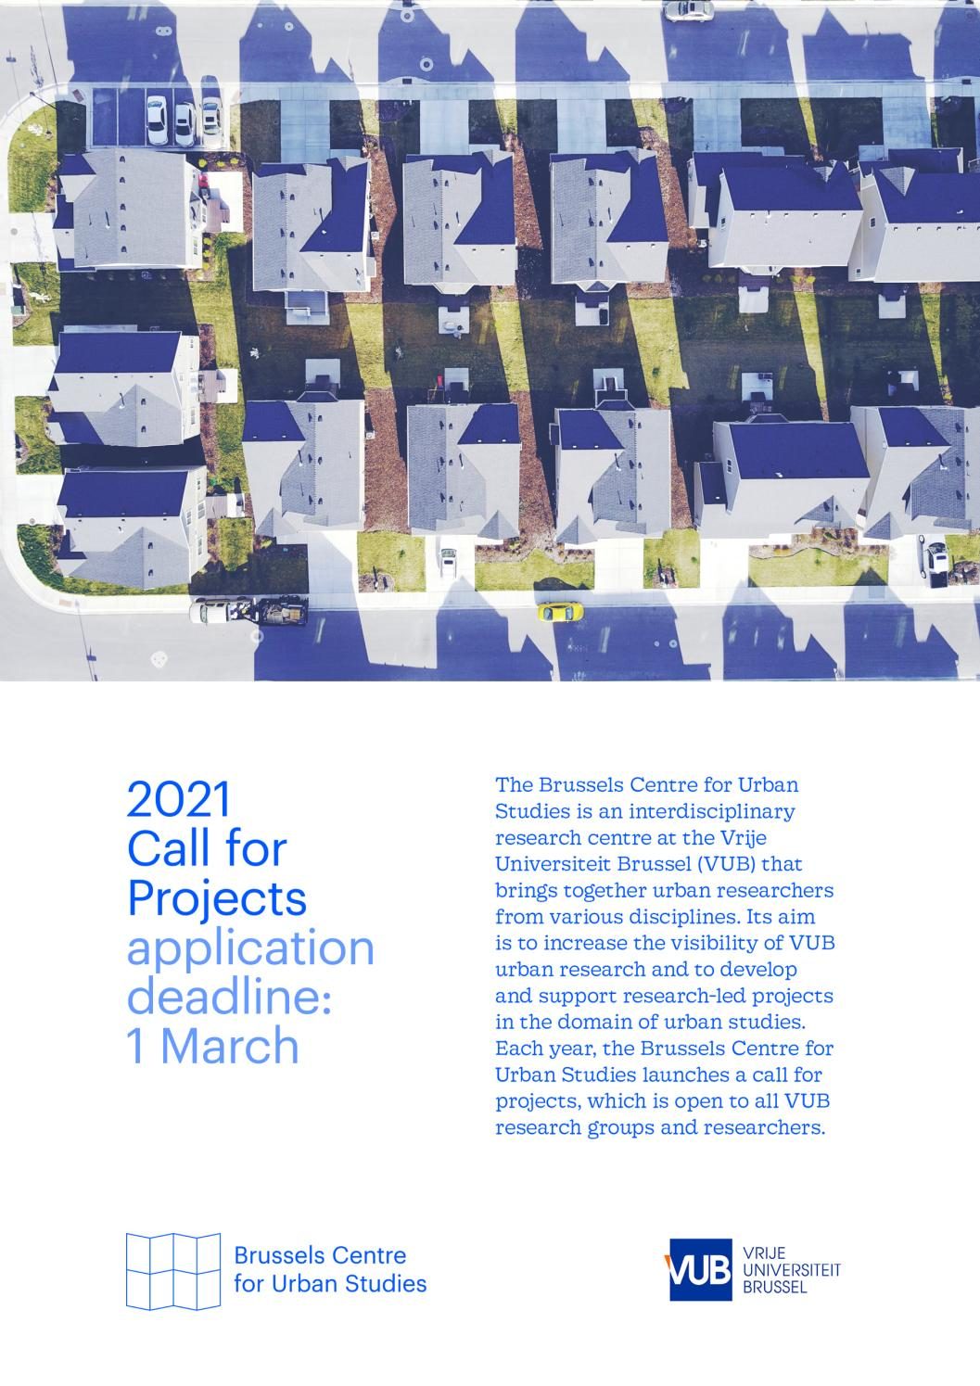
Call for Projects – Application form

The Brussels Centre for Urban Studies is an interdisciplinary research centre at the Vrije Universiteit Brussel (VUB) that brings together urban researchers from various disciplines. Its aim is to increase the visibility of VUB urban research and to develop and support research-led projects in the domain of urban studies.

Each year, the Brussels Centre for Urban Studies launches a call for projects, which is open to all VUB research groups and researchers. Please use this application form and submit it via e-mail to the Centre’s research coordinator Lena Imeraj: Lena.Imeraj@vub.be.

Main applicant
Name:
VUB research group:
Contact e-mail:

Collaborations
If the proposed project involves a structured collaboration with other research groups (VUB or non-VUB (national and international)) and/or non-academic actors/organizations (NGO’s, public administrations, companies, civil society networks, cultural sector), list their details here.

Collaboration 1
Name:
Research group or organization:
Contact e-mail:
Collaboration 2
Name:
Research group or organization:
Contact e-mail:

Project relevance
All kinds of projects can be funded. Important is that the project is of relevance to the Brussels Centre for Urban Studies and engages with one or more of the three overarching research questions that will guide the Centre’s activities for the coming years. Indicate in this section if your proposed project tackles one or more of the questions and if so, how. A focus on Brussels is optional but appreciated in the evaluation.
Inter- and transdisciplinarity: Considering the diversity of disciplinary perspectives on cities and ‘the urban’, what are the key analytical approaches informing your project? Can you identify theoretical and thematic concerns as well as analytical concepts and heuristics that allow for truly inter- and/or transdisciplinary urban research?
Comparative urbanism: Given the socio-spatial unevenness of global urban development, in what ways does your proposed project pay attention to the similarities and differences of cities across space? Considering recent criticisms on the city-centric bias of urban studies, how does your project move beyond a focus on the urban core of a limited set of cities and also pay substantive attention to urban ‘peripheries’ and wider urbanization dynamics?
Engaged research: Embracing the situated nature of urban research, to what extent does your proposed project connect academia with other actors and networks, such as NGOs, civil society, government administrations and businesses? How does this shape the kind of urban knowledge to be produced in your project, and how does this create opportunities for engaged urban research?

Project plan and timing
What concretely do you propose to do? Describe your project plan and timing, indicating when you aim to do what. As all kinds of projects can be funded, the project duration can be a few months only or last for a year or even longer.

Project output
What is the envisioned output of your proposed project? Identify clearly how your output relates to your project plan and the Centre’s research questions. Don’t hesitate to think outside the box: next to the ‘usual’ academic output of seminars, journal articles and funding applications, we are eager to support new and original forms of research-led public engagement.

Project budget
Projects of different sizes and shapes imply a diversity of project budgets. Describe your project budget, including a clear budget breakdown. If your proposed project is also funded through other means (other funding sources, in-kind support), indicate the relation between the support of the Brussels Centre for Urban Studies and the overall budget.

Project funding can be used for all kinds of expenditures, ranging from catering, room rental and travel and accommodation costs to hiring staff, support for visiting researchers, design work, or translation and copy-editing costs. There is no minimum or maximum amount you can apply for. Note, however, that the overall available yearly budget for projects is in the range of € 80.000 and the Centre would like to support a handful of projects each year.

